When More Complexity Does Not Buy Better Tail Risk: A Comparative Study of Skew-t GJR-GARCH and Econometrically Conditioned Temporal Fusion Transformers for Indian Equity Value-at-Risk
Full-Length Reference Draft
Empirical cutoff: 7 September 2026
Draft-use note. This document is intended to be the project's current scientific source of truth. It deliberately excludes deployment/production-engineering material. Numerical claims are tied to the current stored TXT/CSV result summaries and should be revised only after a controlled rerun changes the canonical results.

Abstract
This study examines whether a Temporal Fusion Transformer (TFT) can add useful information to a strong asymmetric econometric benchmark when forecasting extreme downside risk in Indian equity indices. The empirical setting covers the NIFTY50, BANKNIFTY, and NIFTYIT and uses daily observations from January 2015 through a frozen research cutoff of 7 September 2026, with the last observed trading day in the evaluation sample falling on 4 September 2026. The forecasting target is the one-day-ahead 1% conditional return quantile, interpreted as a 99% downside Value-at-Risk (VaR). The benchmark is a point-in-time Skew-t GJR-GARCH(1,1) model with a 1,000-observation rolling estimation window and 21-trading-day parameter refits. Neural models are implemented as a controlled six-arm tournament: the GJR-GARCH benchmark, a raw TFT, a GARCH-conditioned TFT, TFTs augmented separately with US VIX or domestic volatility, and a full Econometrically Conditioned TFT (ECTFT) containing both volatility features. All TFT specifications use the same 21-day encoder, architecture, temporal split, and three pre-specified random seeds; the canonical neural forecast is the mean of the three seed forecasts.
The evidence does not support the proposition that a more complex neural architecture improves 1% VaR forecasting over a well-specified Skew-t GJR-GARCH benchmark. The raw TFT does not significantly outperform GJR-GARCH on any of the three indices. The GARCH-conditioned TFT also fails to establish superiority over GJR-GARCH; on NIFTY50 it is significantly worse at the 5% level. More importantly, adding US VIX and India VIX features to the GARCH-conditioned TFT materially worsens predictive quantile loss: the full ECTFT is significantly inferior to the GARCH-TFT on NIFTY50, BANKNIFTY, and NIFTYIT after Holm correction. The results therefore provide no evidence of incremental VaR value from the additional deep-learning complexity considered here, and they provide positive evidence against adding the macro-volatility features in this sample. VaR coverage diagnostics are broadly non-rejecting, but their inferential power is limited because a 500-day backtest at the 1% level contains only about five expected exceptions. A separate native-calendar Granger analysis finds strong predictive precedence from US VIX innovations to domestic volatility, illustrating an important distinction: a variable may contain statistically detectable predictive information without improving an extreme-quantile forecast once a strong conditional-volatility model is already present. The study concludes with a deliberately narrow claim: for daily 1% VaR of these Indian equity indices over the evaluated sample, model complexity is not justified by demonstrable forecasting gains over the Skew-t GJR-GARCH benchmark.
Keywords: Value-at-Risk; VaR; GJR-GARCH; Skewed Student-t; Temporal Fusion Transformer; quantile forecasting; Indian equities; NIFTY50; volatility spillovers; model comparison

1. Introduction
Extreme downside-risk measurement is a forecasting problem in which statistical discipline matters more than architectural novelty. A one-day-ahead 1% Value-at-Risk (VaR) forecast is intended to locate a very remote conditional return quantile. In such a setting, small improvements in average forecasting accuracy can be difficult to distinguish from estimation noise, while false confidence can have disproportionate consequences. The central question is therefore not whether a model is technologically sophisticated, but whether its additional flexibility produces demonstrable out-of-sample information that a strong benchmark does not already capture.
Classical conditional-volatility models remain difficult to displace in this environment. The autoregressive conditional heteroskedasticity framework of Engle (1982) and its GARCH extension of Bollerslev (1986) provide a compact representation of volatility clustering. The GJR-GARCH specification of Glosten, Jagannathan, and Runkle (1993) adds an explicit leverage effect by allowing negative return innovations to affect conditional variance differently from positive innovations. Pairing the volatility recursion with a Skewed Student-t innovation distribution further allows the conditional return density to accommodate heavy tails and asymmetry (Hansen, 1994). For daily equity returns, this combination is difficult to dismiss as a weak baseline.
At the same time, machine-learning approaches offer a different source of flexibility. Temporal Fusion Transformers (TFTs) combine recurrent processing, gated residual blocks, variable selection, and multi-head attention to learn nonlinear temporal dependencies (Lim et al., 2021). Such mechanisms are attractive in financial forecasting because the relevant information set may contain nonlinear interactions among return history, realized-volatility measures, and external volatility indicators. Yet the same flexibility creates a fundamental statistical problem: daily equity returns have low signal-to-noise ratios, while a 1% tail contains very few observations in any finite evaluation sample. A large sequence model may therefore have difficulty converting extra features into stable tail forecasts.
This study was designed to test that proposition directly. Rather than assuming that a transformer must improve on econometrics, the experiment asks whether a TFT can extract incremental information beyond a strong Skew-t GJR-GARCH prior and, separately, whether cross-market volatility variables add useful information once that prior is already available. The empirical setting consists of three major Indian equity indices—NIFTY50, BANKNIFTY, and NIFTYIT—and a strict 500-observation out-of-sample horizon. The neural side of the study is not represented by a single selected run. Instead, three seeds are fixed ex ante and the canonical forecast is the arithmetic mean of the three seed-specific forecasts. This prevents test-period seed selection from becoming an unobserved form of model tuning.
The paper makes three contributions. First, it provides a point-in-time comparison between a well-specified Skew-t GJR-GARCH benchmark and several TFT variants targeted directly at the 1% quantile. Second, it decomposes the information content of the neural models through a controlled six-arm ablation tournament, separating the value of autoregressive and intraday-volatility information from the incremental contribution of GARCH, US VIX, and domestic volatility features. Third, it demonstrates a useful distinction between statistical predictability and predictive usefulness for tail risk: US VIX innovations strongly precede domestic volatility in a native-calendar Granger framework, yet those features do not improve the final 1% VaR forecast once embedded in the larger neural system.
The main conclusion is deliberately narrow. For daily 1% VaR forecasting of these three Indian equity indices over the evaluated sample, the evidence does not justify replacing the Skew-t GJR-GARCH benchmark with the tested TFT architectures. The conclusion is not that transformers are intrinsically unsuitable for finance, nor that deep learning can never add value to risk forecasting. It is that in this particular low-frequency, extreme-quantile setting, the measured incremental predictive value is absent, while additional macro-feature complexity is actively detrimental. The empirical question is therefore better understood as a test of whether model flexibility is matched to information density.

2. Literature Review and Theoretical Positioning
The literature on volatility forecasting begins with the recognition that asset-return variance is time-varying. Engle (1982) introduced the ARCH model, while Bollerslev (1986) generalized it into the GARCH class. The practical success of these models derives from their ability to describe volatility persistence with relatively few parameters. Their economic usefulness does not require them to reproduce every nonlinear feature of returns; rather, they need to capture the dominant conditional scale sufficiently well.
Asymmetric volatility is particularly important for equity returns. Black (1976) documented the empirical relationship commonly described as the leverage effect, while Glosten et al. (1993) formalized a GARCH-type specification in which the conditional response to negative innovations can differ from the response to positive innovations. The GJR-GARCH model is therefore a natural benchmark for downside-risk forecasting because the left tail is not treated as merely another realization of symmetric volatility dynamics.
Distributional assumptions matter as well. Gaussian innovations impose thin, symmetric tails that are often too restrictive for daily returns. Hansen (1994) proposed a skewed Student-t family that combines heavy tails with flexible asymmetry. This makes a Skew-t GJR-GARCH model a particularly demanding comparator for a machine-learning model whose advantage must come from information not already contained in the conditional-volatility filter.
A parallel literature has investigated machine-learning and neural forecasting methods. Transformer architectures introduced in natural-language processing through self-attention (Vaswani et al., 2017) have been adapted to time series, while the Temporal Fusion Transformer of Lim et al. (2021) combines attention with variable selection and gating mechanisms aimed at interpretability. Financial applications have increasingly considered hybrid GARCH-neural structures; Petrosino et al. (2025), for example, study a GARCH-TFT architecture in volatility prediction. These developments motivate the present question but do not imply that a hybrid model will outperform a strong econometric benchmark in the tail.
The reason is partly statistical. Transformer-style models can represent rich nonlinear functions, but rich representation is only useful when the training data contain enough stable information to identify that function. In daily equity VaR forecasting at the 1% level, the relevant tail event is intentionally rare. A 500-observation test window contains an expected five exceedances under correct 1% coverage. Deep sequence models therefore operate in an environment in which the effective number of observations directly informative about the target tail is small relative to the model's expressive capacity.
The present study is also related to the literature on filtered tail-risk estimation. McNeil and Frey (2000) emphasize the importance of conditional volatility filtering for tail-related risk measurement, while Engle and Manganelli (2004) demonstrate a direct regression-based framework for conditional quantile evaluation. These ideas suggest a useful hierarchy for the current experiment: first extract the dominant conditional volatility structure econometrically, then ask whether a flexible nonlinear learner adds information that remains after that structure is accounted for.
Finally, the study uses Granger's predictive-precedence concept to examine cross-market volatility transmission. The purpose is not to establish structural causation. Instead, the test asks whether lagged US VIX innovations contain incremental predictive information for domestic volatility changes. This is intentionally kept separate from the VaR experiment. Detectable cross-market predictive precedence is not treated as evidence that the same information must improve a 1% quantile forecast. The distinction is central to the paper's interpretation: statistical significance in an auxiliary time-series relation does not automatically translate into economically useful tail-risk prediction.

3. Research Questions and Hypotheses
The empirical design is organized around a primary question and three secondary questions.
RQ1. Can a raw Temporal Fusion Transformer materially improve one-day-ahead 1% VaR forecasting relative to a Skew-t GJR-GARCH benchmark?
RQ2. Does conditioning the TFT on a point-in-time GJR-GARCH volatility prior improve the neural forecast relative to the raw TFT, and does it produce lower predictive loss than GJR-GARCH itself?
RQ3. Do external volatility indicators—US VIX and domestic volatility—provide incremental predictive value after GARCH conditioning, or do they worsen generalization in the low-signal tail regime?
RQ4. Does strong predictive precedence from US VIX to domestic volatility translate into measurable incremental value for 1% VaR forecasting?
The hypotheses are deliberately stated in two-sided comparative form. H1: the raw TFT has lower expected pinball loss than GJR-GARCH. H2: the GARCH-conditioned TFT has lower expected pinball loss than GJR-GARCH and lower loss than the raw TFT. H3: adding US VIX and domestic volatility to the GARCH-conditioned TFT further reduces expected pinball loss. H4: evidence of US-to-domestic volatility predictive precedence is accompanied by improved tail-quantile forecasting. The empirical results do not support these improvement hypotheses; instead, the evidence favors the benchmark and rejects the incremental usefulness of the full macro-enhanced specification.
Table 1. Research questions and directional hypotheses
Question | Tested proposition
RQ1 / H1 | Raw TFT has lower 1% pinball loss than GJR-GARCH.
RQ2 / H2 | GARCH conditioning improves TFT loss and/or establishes improvement over GJR-GARCH.
RQ3 / H3 | Adding US VIX and domestic volatility to GARCH-TFT reduces OOS 1% pinball loss.
RQ4 / H4 | US VIX predictive precedence translates into incremental 1% VaR forecasting value.

4. Data and Methodology
4.1 Data coverage and target construction. The dataset contains daily OHLCV observations for NIFTY50 (^NSEI), BANKNIFTY (^NSEBANK), and NIFTYIT (^CNXIT), beginning in January 2015. The research horizon is frozen at 7 September 2026 so that rerunning the pipeline does not change the empirical sample as the calendar advances. Because 7 September 2026 is not itself a final observation date in the market-data sample, the latest observed trading day in the reported evaluation window is 4 September 2026. Continuous-compound percentage returns are defined as r_t = 100[ln(P_t) - ln(P_{t-1})].
The target is the next-day conditional 1% return quantile, q_{0.01,t+1}. A breach occurs whenever the realized next-day return falls below the forecast quantile. The 1% level is intentionally demanding: under perfect unconditional coverage, only 1% of observations should breach the threshold.
4.2 Point-in-time information discipline. The data pipeline explicitly separates variables by their information timing. The US VIX series is lagged conservatively to avoid contamination from the US session that closes after the Indian market has already closed. The domestic volatility feature is likewise lagged before entering the neural model. The Granger analysis is handled separately: it uses native-calendar daily log-differences and an inner join on genuinely shared trading dates, rather than the shifted machine-learning features. This prevents the forward-filled ML representation from being mistaken for an econometric observation.
4.3 Intraday range-volatility feature. Daily Garman-Klass volatility is calculated from the OHLC range. The variance proxy is GK_t = 0.5[ln(H_t/L_t)]^2 - [2ln(2)-1][ln(C_t/O_t)]^2, with the square root converted to an annualized percentage volatility measure. The feature is supplied to every TFT arm as part of the common autoregressive and intraday-information block.
4.4 Point-in-time Skew-t GJR-GARCH benchmark. The benchmark uses a GJR-GARCH(1,1) conditional variance recursion, sigma_t^2 = omega + [alpha + gamma I(epsilon_{t-1}<0)]epsilon_{t-1}^2 + beta sigma_{t-1}^2, with a constant conditional mean and Skewed Student-t innovations. Parameters are re-estimated every 21 trading days on the trailing 1,000 observations. The resulting one-step-ahead conditional volatility is combined with the fitted Skew-t 1% quantile to generate the econometric VaR forecast. All benchmark values entering the OOS test are generated using only information available before the forecast date.
The three full-sample descriptive parameter estimates are informative about the character of the data, although they are not themselves the OOS forecast parameters. NIFTY50 has omega = 0.03139, alpha = 0.00662, gamma = 0.14098, beta = 0.88624, nu = 6.90, and lambda = -0.158. BANKNIFTY has omega = 0.03216, alpha = 0.04755, gamma = 0.10988, beta = 0.88373, nu = 5.26, and lambda = -0.083. NIFTYIT has omega = 0.06469, alpha = 0.01705, gamma = 0.05598, beta = 0.92424, nu = 4.53, and lambda = 0.008. The estimates indicate substantial persistence and heavy tails, with meaningful asymmetry particularly in NIFTY50 and BANKNIFTY.
4.5 TFT architecture. The neural model is a Temporal Fusion Transformer with hidden size 64, four attention heads, 30% dropout, learning rate 0.001552, batch size 64, gradient clipping at 0.1, and a maximum of 80 epochs with early stopping. The encoder spans 21 observations and the prediction horizon is one day. The model predicts the 0.01, 0.50, and 0.99 quantiles jointly. Quantile forecasts are scored with the pinball loss, L_q(y,qhat) = max(q(y-qhat),(q-1)(y-qhat)), evaluated at q = 0.01 for the main VaR comparison.
The TFT receives two common unknown-at-forecast-time inputs in every arm: historical log returns and Garman-Klass volatility. The model uses bounded relative temporal indexing rather than an unrestricted calendar time index. The GARCH-conditioned specifications add GARCH_sigma as a known feature, while the macro arms add US_VIX_Diff, India_VIX_Diff, or both. The raw target series is not exposed to the decoder as a future feature; its historical values are passed through the encoder as an autoregressive input.
4.6 Six-arm ablation tournament. The experimental arms are: (0) Skew-t GJR-GARCH benchmark; (1) Raw TFT; (2) GARCH-TFT; (3) US-VIX TFT; (4) India-VIX TFT; and (5) Full ECTFT with GARCH sigma, US VIX changes, and domestic volatility changes. All TFT arms share the same training/validation/test partition, architecture, encoder length, and seeds. The evaluation uses 250 validation observations followed by a 500-observation OOS window. The OOS interval runs from 29 August 2024 through 4 September 2026 for all three indices.
To reduce sensitivity to random initialization, all neural results are generated for seeds 42, 123, and 777. The canonical forecast for each arm is the arithmetic mean of the three seed-specific q_{0.01} forecasts. Quantile monotonicity is audited at both the seed and ensemble level. No test-selected seed is used for the headline results.
4.7 Statistical comparison. Predictive accuracy is assessed using the Diebold-Mariano (DM) framework with the 1% pinball loss. For a pair of models A and B, the loss differential is defined as d_t = L_t(B) - L_t(A). Under this convention a negative DM statistic indicates that the second model has lower predictive loss. Direct pairwise tests are reported for Full ECTFT versus GARCH-TFT, Full ECTFT versus GJR-GARCH, US-only versus GARCH-TFT, and India-only versus GARCH-TFT. Holm-Bonferroni adjustment is applied within each three-asset comparison family.
4.8 VaR coverage diagnostics. The study reports the Kupiec unconditional-coverage test, the Christoffersen independence test, and the Engle-Manganelli dynamic quantile (DQ) test. A sample-size-adapted binomial coverage label is also reported as a descriptive device. It is not presented as formal Basel traffic-light compliance. The interpretation of all coverage tests is conservative: non-rejection means that the sample provides insufficient evidence of failure; it is not treated as proof of correct calibration.
4.9 Cross-market predictive precedence. A separate Granger analysis is conducted using the native-calendar daily log-differences of US VIX and domestic volatility, inner-joined on shared trading dates. The tests cover 1-, 2-, and 5-day lag horizons. ADF tests assess stationarity, and zero/duplicate fractions are checked to identify possible calendar-forward-fill artifacts. The test is interpreted as predictive precedence rather than structural causation.
4.10 Explainability diagnostics. The Variable Selection Network (VSN) weights and temporal attention distributions are aggregated across the three seeds. These statistics are treated as model-internal allocation diagnostics rather than causal feature importance. Their purpose is descriptive: to identify which inputs the trained networks allocate capacity to and whether the attention mechanism concentrates on a small subset of lags.
Table 2. Experimental design
Component | Specification
Assets | NIFTY50, BANKNIFTY, NIFTYIT
Research window | 2015-01-01 to frozen cutoff 2026-09-07
OOS horizon | 500 trading observations; 2024-08-29 to 2026-09-04
Validation window | 250 observations
Encoder | 21 trading days
Target | Next-day q=0.01 return quantile
TFT seeds | 42, 123, 777; mean-of-seed ensemble
GARCH | Skew-t GJR-GARCH(1,1); 1,000-day rolling window; 21-day refits
Main loss | 1% pinball loss
Multiple-testing correction | Holm-Bonferroni within each 3-asset DM family
Table 3. Six-arm ablation tournament
Arm | Model | Known features
0 | Skew-t GJR-GARCH | —
1 | Raw TFT | None beyond common historical-return + GK block
2 | GARCH-TFT | GARCH_sigma
3 | US-VIX TFT | GARCH_sigma + US_VIX_Diff
4 | India-VIX TFT | GARCH_sigma + India_VIX_Diff
5 | Full ECTFT | GARCH_sigma + US_VIX_Diff + India_VIX_Diff

5. Empirical Results
5.1 Distributional and econometric characteristics. The return distributions exhibit the stylized features that motivate the benchmark choice: heavy tails, volatility clustering, and asymmetric responses to negative shocks. The fitted Skew-t GJR-GARCH parameters are consistent with a persistent conditional-volatility process. In all three series, the persistence components are large, while the estimated tail degrees of freedom are low enough to imply substantial tail thickness. NIFTY50 has the most pronounced negative skew parameter among the three indices, while NIFTYIT has an estimated skew parameter close to zero but still exhibits heavy tails through its low estimated degrees of freedom.
The parameter estimates also illustrate why the benchmark is demanding. The GJR asymmetry coefficient is 0.1410 for NIFTY50, 0.1099 for BANKNIFTY, and 0.0560 for NIFTYIT. Thus the benchmark explicitly distinguishes negative from positive shocks rather than asking the neural model to rediscover leverage asymmetry from a relatively small tail sample. The combination of GARCH persistence and Skew-t innovations supplies both conditional scale dynamics and a flexible tail shape.
5.2 Cross-market volatility predictive precedence. The native-calendar Granger analysis produces extremely small forward-direction p-values at the tested horizons: US VIX innovations have significant predictive precedence for domestic volatility at 1-, 2-, and 5-day lags for all three indices, with the reported p-values below the display precision of 0.0001. The input diagnostics are supportive: ADF p-values are below 0.0001, while the exact-zero fraction is about 0.44% for the US VIX difference series and 0.77% for the domestic series, with duplicate fractions reported as 0.00%. These checks do not prove that the spillover relation is structural, but they make a trivial calendar-forward-fill explanation less plausible.
This finding is important precisely because it does not settle the VaR question. The existence of predictive precedence in volatility is a weaker claim than the existence of incremental predictive power for the one-day 1% return quantile. The latter must be demonstrated through OOS quantile loss, not inferred from a separate Granger regression.
5.3 Absolute VaR backtesting. The canonical three-seed Full ECTFT ensemble generates 2 breaches for NIFTY50, 2 for BANKNIFTY, and 5 for NIFTYIT over the 500-day OOS window. These correspond to breach rates of 0.40%, 0.40%, and 1.00%, respectively. Kupiec p-values are 0.125, 0.125, and 1.000. Christoffersen independence p-values are 0.899, 0.899, and 0.750, while DQ p-values are 0.931, 0.910, and 0.995. The descriptive coverage zone is therefore green for all three series under the project's sample-size-adapted classification.
These results should not be interpreted as a demonstration of perfect calibration. At alpha = 0.01, a 500-observation sample contains only about five expected exceptions. The difference between two, five, or even eight realized exceptions can therefore occur without implying a decisive model-quality ranking. Coverage tests remain useful as failure diagnostics, but predictive-loss comparisons carry more weight for determining whether one forecasting model is actually better than another in this study.
The GJR-GARCH benchmark itself records 3, 2, and 8 breaches for NIFTY50, BANKNIFTY, and NIFTYIT, respectively, with Kupiec p-values of 0.3315, 0.1250, and 0.2149. Thus the benchmark does not exhibit evidence of unconditional-coverage failure either. The comparison again reinforces the central point: the benchmark already behaves plausibly under basic VaR diagnostics, so a neural model must show an incremental loss advantage rather than merely acceptable coverage.
5.4 The six-arm tournament: predictive loss. The central result appears in the paired predictive-loss comparisons. Relative to GJR-GARCH, the Raw TFT has positive mean loss differences on all three indices—0.001383 for NIFTY50, 0.000229 for BANKNIFTY, and 0.000661 for NIFTYIT—with DM p-values of 0.3357, 0.8698, and 0.8636. The sign indicates that the GJR-GARCH benchmark has lower average pinball loss in each case, although the difference is not statistically significant in this three-asset comparison.
The GARCH-TFT does not reverse this result. Its mean loss differences relative to GJR-GARCH are 0.003531 for NIFTY50, 0.002299 for BANKNIFTY, and 0.002746 for NIFTYIT. The corresponding DM p-values are 0.0181, 0.0983, and 0.4504. Thus the GARCH-conditioned neural model is significantly worse than GJR-GARCH on NIFTY50 at the 5% level and not significantly different on the other two indices. In other words, GARCH conditioning does not create evidence of a neural improvement over the econometric benchmark.
The macro-enhanced arms do not produce a rescue. The US-only specification has DM p-values of 0.0730, 0.3484, and 0.3609 relative to GARCH-TFT for NIFTY50, BANKNIFTY, and NIFTYIT. The India-only specification has p-values of 0.1554, 0.5646, and 0.5926. Most importantly, the Full ECTFT is significantly worse than the GARCH-TFT on all three indices after Holm correction. For Full versus GARCH-TFT the DM statistics are 2.6032, 12.0976, and 2.2855, with Holm-adjusted p-values of 0.0185, below 0.0001, and 0.0223. Because the second model in each comparison is GARCH-TFT, the positive DM statistics indicate lower pinball loss for the GARCH-conditioned TFT than for the full macro-enhanced specification.
The Full ECTFT also fails to demonstrate improvement over GJR-GARCH directly. The Full-vs-GJR DM statistics are -1.7326, -0.7945, and -0.1955 under the sign convention d_t = L_GJR - L_Full, with p-values of 0.0832, 0.4269, and 0.8450. The negative sign means that GJR-GARCH has lower loss than the Full ECTFT in these comparisons, but the differences are not statistically significant at conventional levels. The proper interpretation is therefore not that the two models are equivalent; it is that the sample does not provide sufficient evidence to reject equal predictive loss, while the direct Full-vs-GARCH-TFT comparisons clearly favor the simpler GARCH-conditioned neural specification.
Taken together, the tournament yields a hierarchy rather than a victory for deep learning. GJR-GARCH is a strong benchmark. A raw TFT does not beat it. Adding GARCH_sigma does not make the TFT better than GJR-GARCH. Adding macro-volatility variables to the GARCH-conditioned model makes the forecast significantly worse. The most defensible conclusion is therefore that the additional representational capacity tested here fails to generate incremental 1% VaR information and, in the full model, appears counterproductive.
5.5 Seed sensitivity. The three-seed analysis reveals meaningful initialization sensitivity in the neural models. For the Full ECTFT, NIFTY50 breach counts across seeds are 3, 3, and 1; BANKNIFTY counts are 2, 3, and 1; and NIFTYIT counts are 4, 7, and 2. DM p-values for Full ECTFT versus GJR-GARCH are likewise heterogeneous: NIFTY50 yields 0.0044, 0.7720, and 0.0267 across the three seeds, while the corresponding loss differences vary in sign for BANKNIFTY and remain positive for most NIFTY50/NIFTYIT specifications. This is precisely why the paper does not select the best-performing test seed. The ensemble is fixed ex ante, and the seed-level dispersion is itself evidence about model stability.
The variability also cautions against interpreting a single highly favorable run as evidence of a robust neural advantage. If a model's comparative result changes substantially with initialization, a production or research claim should either average over seeds, characterize the distribution of outcomes, or demonstrate that the optimization is sufficiently stable that seed selection no longer matters. The present study chooses the first approach.
5.6 Explainability: feature allocation and temporal attention. The aggregated VSN weights are approximately 31.14% for historical returns, 18.69% for Garman-Klass volatility, 16.42% for US VIX changes, 12.88% for domestic volatility changes, 12.36% for relative temporal indexing, and 8.50% for GARCH sigma. The corresponding seed-to-seed standard deviations are 20.19, 26.22, 10.83, 8.33, 7.97, and 4.39 percentage points. These numbers show that the network allocates substantial capacity to the macro features, but they do not establish causal importance or quantify the exact amount of predictive information attributable to each variable.
Temporal attention is strikingly diffuse. Across the 21-day encoder, the aggregated weights range only from about 4.71% to 4.91%, close to the uniform 4.76% benchmark implied by 1/21. The appropriate interpretation is therefore that the model does not assign overwhelming attention to a single recent lag. It is not evidence, by itself, that the network has discovered a structural long-memory mechanism.
The explainability results are consistent with the main performance finding. The full model uses a meaningful amount of representational capacity on US and domestic volatility inputs, yet the resulting forecast has higher OOS pinball loss than the leaner GARCH-TFT. This is consistent with—but does not by itself prove—overfitting or redundancy in the macro channels.
Table 4. Full ECTFT versus GARCH-TFT: direct paired DM tests
Asset | DM stat | Raw p | Holm p | Interpretation
NIFTY50 | 2.6032 | 0.0092 | 0.0185 | GARCH-TFT lower loss
BANKNIFTY | 12.0976 | <0.0001 | <0.0001 | GARCH-TFT lower loss
NIFTYIT | 2.2855 | 0.0223 | 0.0223 | GARCH-TFT lower loss
Table 5. Full ECTFT versus GJR-GARCH: direct paired DM tests
Asset | DM stat | p | Mean loss diff | Interpretation
NIFTY50 | -1.7326 | 0.0832 | -0.002434 | GJR lower loss; not significant at 5%
BANKNIFTY | -0.7945 | 0.4269 | -0.001092 | GJR lower loss; not significant
NIFTYIT | -0.1955 | 0.8450 | -0.000799 | GJR lower loss; not significant
Table 6. Ensemble tournament: performance relative to GJR-GARCH
Model | Asset | Breaches | Kupiec p | DM stat | DM p | Mean loss diff
Raw TFT | NIFTY50 | 2 | 0.1250 | 0.9628 | 0.3357 | 0.001383
Raw TFT | BANKNIFTY | 3 | 0.3315 | 0.1639 | 0.8698 | 0.000229
Raw TFT | NIFTYIT | 6 | 0.6630 | 0.1718 | 0.8636 | 0.000661
GARCH-TFT | NIFTY50 | 1 | 0.0282 | 2.3628 | 0.0181 | 0.003531
GARCH-TFT | BANKNIFTY | 1 | 0.0282 | 1.6532 | 0.0983 | 0.002299
GARCH-TFT | NIFTYIT | 5 | 1.0000 | 0.7547 | 0.4504 | 0.002746
US-only | NIFTY50 | 2 | 0.1250 | 1.7931 | 0.0730 | 0.002649
US-only | BANKNIFTY | 1 | 0.0282 | 0.9376 | 0.3484 | 0.001439
US-only | NIFTYIT | 5 | 1.0000 | 0.9137 | 0.3609 | 0.003091
India-only | NIFTY50 | 2 | 0.1250 | 1.4208 | 0.1554 | 0.002086
India-only | BANKNIFTY | 2 | 0.1250 | 0.5760 | 0.5646 | 0.000795
India-only | NIFTYIT | 5 | 1.0000 | 0.5350 | 0.5926 | 0.001811
Full ECTFT | NIFTY50 | 2 | 0.1250 | 1.7326 | 0.0832 | 0.002434
Full ECTFT | BANKNIFTY | 2 | 0.1250 | 0.7945 | 0.4269 | 0.001092
Full ECTFT | NIFTYIT | 5 | 1.0000 | 0.1955 | 0.8450 | 0.000799
Table 7. Canonical Full ECTFT VaR backtest
Asset | Obs. | Breaches | Rate | Kupiec p | Christoffersen p | DQ p
NIFTY50 | 500 | 2 | 0.40% | 0.125 | 0.8990 | 0.9309
BANKNIFTY | 500 | 2 | 0.40% | 0.125 | 0.8990 | 0.9100
NIFTYIT | 500 | 5 | 1.00% | 1.000 | 0.7504 | 0.9950
Table 8. Full-sample descriptive Skew-t GJR-GARCH estimates
Asset | Omega | Alpha | Gamma | Beta | nu | lambda
NIFTY50 | 0.03139 | 0.00662 | 0.14098 | 0.88624 | 6.90 | -0.158
BANKNIFTY | 0.03216 | 0.04755 | 0.10988 | 0.88373 | 5.26 | -0.083
NIFTYIT | 0.06469 | 0.01705 | 0.05598 | 0.92424 | 4.53 | 0.008
Table 9. VSN allocation across the three-seed Full ECTFT ensemble
Feature | Mean weight | Std. dev.
Log_Ret_Feature | 31.14% | 20.19%
GK_Vol | 18.69% | 26.22%
US_VIX_Diff | 16.42% | 10.83%
India_VIX_Diff | 12.88% | 8.33%
relative_time_idx | 12.36% | 7.97%
GARCH_sigma | 8.50% | 4.39%

6. Discussion
6.1 The benchmark problem is harder than the architecture problem. The most important methodological lesson from this experiment is that model comparison should begin by asking whether the benchmark already captures the dominant signal. The Skew-t GJR-GARCH specification is not a straw-man model: it explicitly models volatility persistence, leverage asymmetry, and tail shape. A neural model that receives only a finite daily history must compete with a benchmark that already imposes a structure closely aligned with the target phenomenon.
In this setting the TFT does not demonstrate a statistically reliable predictive advantage. This finding matters because it changes how the model-development problem should be framed. The objective is not to maximize architectural flexibility but to identify the smallest information set and model class that produce a stable out-of-sample quantile forecast. If two models are not distinguishable in predictive loss, additional complexity requires a separate justification—such as materially better behavior during regime breaks, better multivariate risk aggregation, or an operational objective not captured by the present loss function.
6.2 Predictability is not the same as useful tail-risk information. The Granger analysis demonstrates strong US-to-domestic volatility predictive precedence. Yet the same US VIX feature fails to improve the final VaR forecast when introduced into the neural architecture, and the full combination of US and domestic volatility features makes the forecast significantly worse than the GARCH-conditioned model. This result is not contradictory. Granger predictive precedence concerns whether lagged values improve the prediction of another time series under a specified linear dynamic system. The VaR experiment asks whether the information changes the forecast of a very remote quantile of the next return distribution after the dominant conditional-volatility structure is already represented. The two estimands are different.
This distinction suggests a general warning for machine-learning finance research: feature significance in an auxiliary regression should not be used as a proxy for out-of-sample value in the final task. A variable can contain real predictive information, be economically interpretable, and still fail to justify inclusion in a high-capacity tail model because its incremental information is redundant, unstable, too weak relative to the target noise, or difficult for the learner to exploit reliably.
6.3 The macro-noise interpretation is plausible but not identified as a single mechanism. The observed deterioration in the Full ECTFT is consistent with the hypothesis that additional volatility features increase estimation variance in a low-SNR setting. The VSN results reinforce that interpretation because the model allocates nearly 30% of its aggregate feature weight to the two macro-volatility channels despite the negative comparative loss result. However, the experiment does not establish that overfitting is the unique cause. Redundancy, lag design, feature scaling, optimization interactions, and finite-sample instability are alternative explanations. The appropriate scientific statement is therefore that the evidence is consistent with macro-feature noise or overfitting and inconsistent with a claim of incremental VaR benefit.
6.4 Implications for model selection. The empirical results point toward a simple model-selection principle for this use case: complexity should be purchased only when it produces measurable incremental information. A Skew-t GJR-GARCH model is computationally light, transparent, easy to stress-test, and naturally interpretable in terms of volatility persistence and leverage. A multi-seed TFT requires neural-network training, hyperparameter control, checkpoint management, reproducibility safeguards, and a substantially more complicated data representation. None of those costs are automatically justified by architectural sophistication. In the present sample, the measured VaR loss evidence does not provide that justification.
This does not mean that a TFT should never be used in market risk. The conclusion is conditional on the information environment and target examined here: daily 1% VaR for three Indian equity indices. Intraday data, richer realized measures, cross-sectional portfolios, option-implied distributions, limit-order-book variables, nonlinear dependence across many assets, or more densely observed tail-relevant covariates may provide a very different signal-to-noise ratio. The correct lesson is not 'deep learning fails in finance,' but rather 'deep learning should not be assumed to add value when the target can already be forecast well by a structurally aligned econometric model.'
6.5 Why the paper does not claim equivalence. A non-significant DM test is frequently misinterpreted as proof that two models are equal. This paper explicitly avoids that language. For the Full ECTFT versus GJR-GARCH comparison, the absence of a statistically significant difference means that the present sample does not establish superiority in either direction. The stronger evidence comes from the Full-versus-GARCH-TFT comparison, where the full model is significantly worse on all three indices after multiple-testing adjustment. Thus the paper distinguishes failure to establish an improvement from affirmative evidence of deterioration.
6.6 Why the paper does not claim calibrated certainty. The 500-day test window contains only around five expected 1% exceptions. This limits the power of coverage tests and makes any strong statement about absolute tail calibration premature. The correct role of the coverage diagnostics is therefore to detect obvious failure, not to certify the model. The loss comparisons answer the relative-forecasting question more directly because every test day contributes a quantile-loss observation, not only the rare breach days.

7. Robustness, Limitations, and Threats to Validity
Several limitations should constrain the interpretation of the results.
First, the OOS horizon is 500 trading days. This is substantial for a single contiguous backtest, but at the 1% tail level it remains statistically sparse. A longer historical evaluation, multiple rolling OOS windows, or repeated crisis/non-crisis subsamples would provide stronger evidence about whether the ranking is stable across regimes.
Second, the neural architecture is controlled but not exhaustive. The results apply to the committed TFT configuration and its tested feature sets, not to all transformer architectures. A different encoder length, regularization scheme, training objective, quantile parameterization, or representation of the macro information could produce different outcomes. The paper therefore claims no universal dominance of econometric models.
Third, the cross-border feature timing is deliberately conservative. The US VIX feature is lagged to ensure that the information is definitely available at the Indian market close, while domestic volatility is also lagged in the ML feature set. Alternative timing conventions could alter the amount of usable macro information. This is a valid design choice for look-ahead control, but it means the present experiment should be interpreted as a test under the chosen information set.
Fourth, the Granger analysis is auxiliary and exploratory. Its p-values are not Holm-corrected across all lag/direction tests, and Granger predictive precedence is not structural causality. The analysis is included to characterize the information relationship between the markets, not to establish an economic mechanism for the VaR result.
Fifth, the explainability analysis is descriptive. VSN weights and attention distributions are model-internal quantities. They should not be treated as causal feature importance, and a flat attention profile should not be interpreted as proof of structural long memory.
Sixth, the tail-depth statistic is a descriptive breach-severity diagnostic rather than a formal Expected Shortfall backtest. The study reports mean standardized breach depth for context but does not claim ES validation. A future paper that wishes to address FRTB-style expected-shortfall objectives should adopt a dedicated ES forecast and an appropriate conditional backtesting framework.
Seventh, the GJR-GARCH benchmark itself is not the only possible strong classical comparator. More flexible volatility models, realized-volatility models, stochastic-volatility specifications, and filtered historical simulation could provide additional baselines. The present conclusion is therefore best understood as a comparison against one carefully specified and economically motivated benchmark rather than a proof that all classical approaches dominate neural alternatives.
Finally, the study uses three Indian equity indices. The conclusion may not generalize to individual stocks, options, credit portfolios, commodities, currencies, intraday markets, or high-dimensional cross-sectional risk. External validity must therefore be earned through additional datasets rather than assumed.

8. Practical Interpretation
The practical implication is straightforward. If the sole objective is to minimize one-day-ahead 1% VaR forecast loss for the three indices studied here, the current evidence does not justify the added complexity of the tested TFT systems. The Skew-t GJR-GARCH benchmark is already competitive in the OOS tournament, exhibits plausible coverage behavior, and provides an interpretable conditional-volatility structure. The Raw TFT adds no statistically significant improvement. The GARCH-TFT does not establish improvement over GJR-GARCH, and the Full ECTFT is significantly worse than the GARCH-TFT on all three assets.
This does not mean that the TFT work was wasted. On the contrary, the ablation experiment identifies a useful negative result. It shows that strong econometric priors are difficult to improve upon when the target is an extreme daily quantile and when the available exogenous information is sparse relative to model flexibility. It also shows that a variable can have strong predictive precedence in a volatility equation while contributing no useful incremental information to the ultimate risk forecast. Those findings are relevant to model governance because they discourage complexity for its own sake.

9. Conclusion and Future Research
This paper investigated whether a Temporal Fusion Transformer could improve one-day-ahead 1% VaR forecasting for NIFTY50, BANKNIFTY, and NIFTYIT relative to a point-in-time Skew-t GJR-GARCH benchmark, and whether US and domestic volatility indicators added incremental predictive information beyond the econometric prior. The answer from the present experiment is negative in its strongest practical form.
The Skew-t GJR-GARCH benchmark is highly competitive. The raw TFT does not significantly outperform it on any of the three indices. The GARCH-conditioned TFT does not establish a predictive advantage over the benchmark and is significantly worse on NIFTY50. Adding US VIX or domestic volatility separately does not yield robust improvement over the GARCH-conditioned specification. Adding both produces the clearest negative result: the Full ECTFT has significantly higher 1% pinball loss than the GARCH-TFT on NIFTY50, BANKNIFTY, and NIFTYIT after Holm correction.
The absolute VaR diagnostics are not inconsistent with a usable model: the Full ECTFT produces 2, 2, and 5 breaches over 500 observations, with non-rejecting Kupiec, Christoffersen, and DQ tests. But the small expected number of tail events prevents strong claims of calibration. The comparative loss evidence is therefore the more important basis for the model-selection conclusion.
The cross-market analysis adds a second lesson. US VIX innovations have strong predictive precedence for domestic volatility on shared trading dates, yet this information does not translate into improved 1% VaR forecasting once the model is asked to learn the tail quantile in a flexible neural architecture. Predictive information is not synonymous with economically useful incremental information for every downstream task.
The broader implication is one of model proportionality. A forecasting model should be as complex as the information environment requires, but no more complex than the evidence can support. In the present low-frequency tail-risk setting, the available evidence favors the parsimonious econometric benchmark over the more elaborate neural alternatives. Future work should therefore focus not on making the transformer larger, but on identifying settings with genuinely denser tail information: intraday realized measures, option-implied distributions, richer cross-sectional inputs, multi-asset dependence structures, or longer multi-regime evaluation windows. Those are the conditions under which a flexible learner would have a more credible opportunity to earn its complexity premium.

10. Figures for the Reference Draft
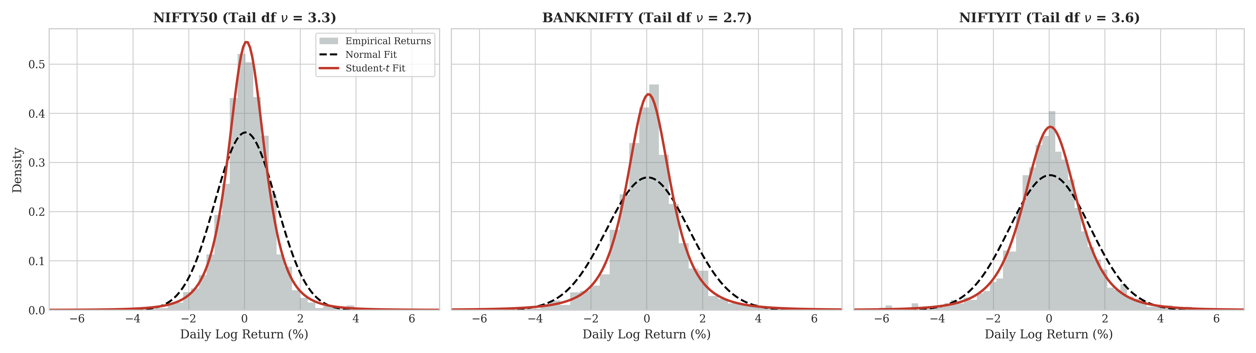
Figure 1. Return distribution fits across the three indices.

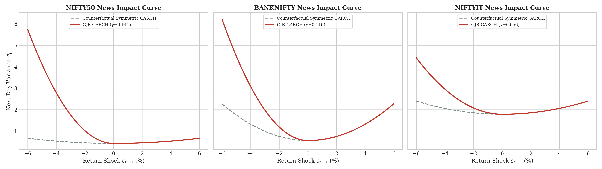
Figure 2. GJR-GARCH news-impact curves.

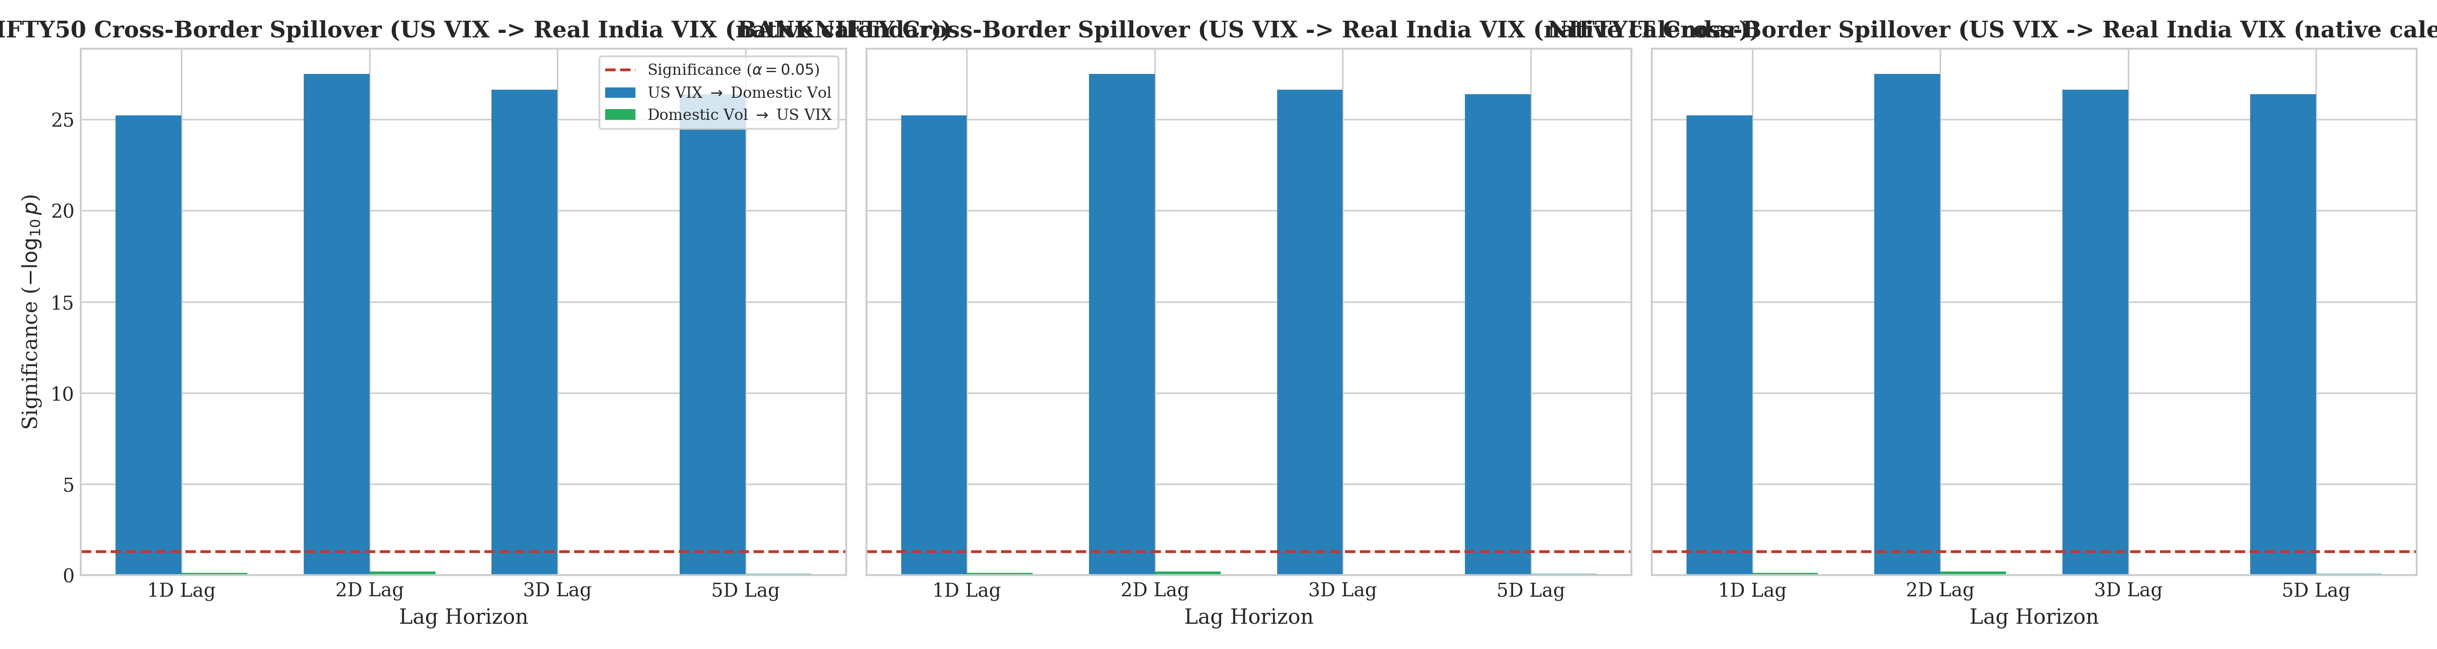
Figure 3. Native-calendar US VIX predictive-precedence diagnostics.

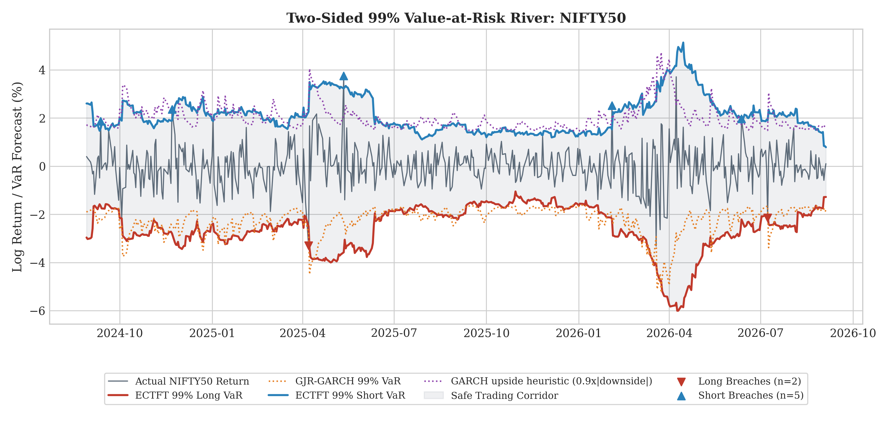
Figure 4a. NIFTY50 two-sided 99% VaR risk river.

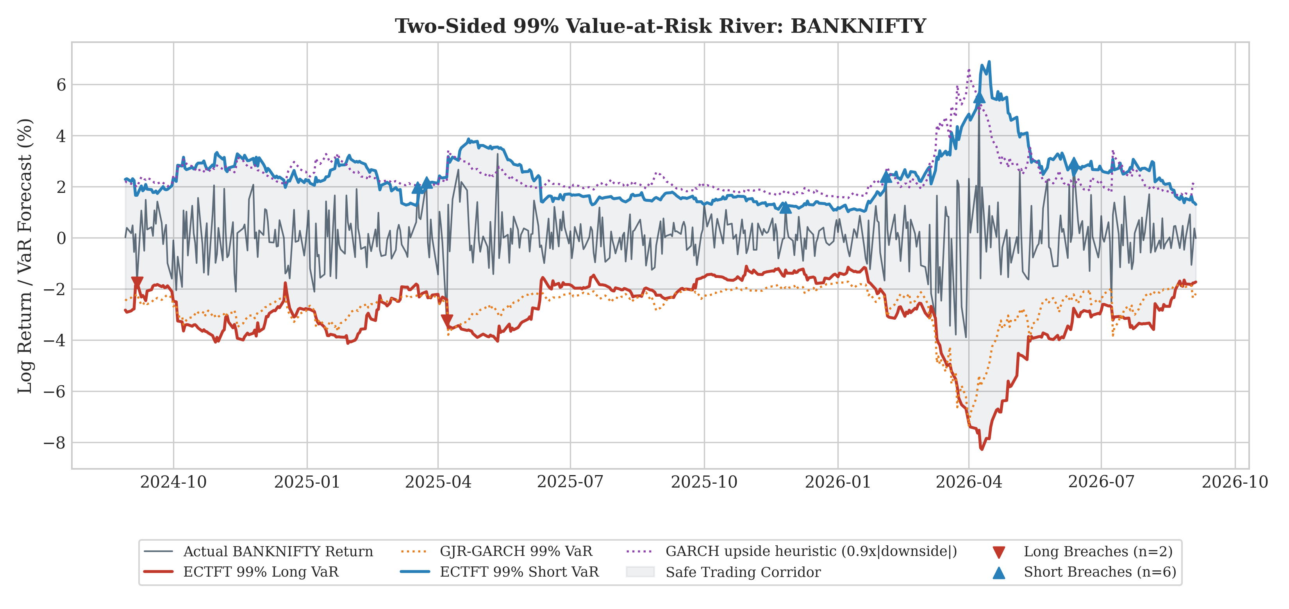
Figure 4b. BANKNIFTY two-sided 99% VaR risk river.

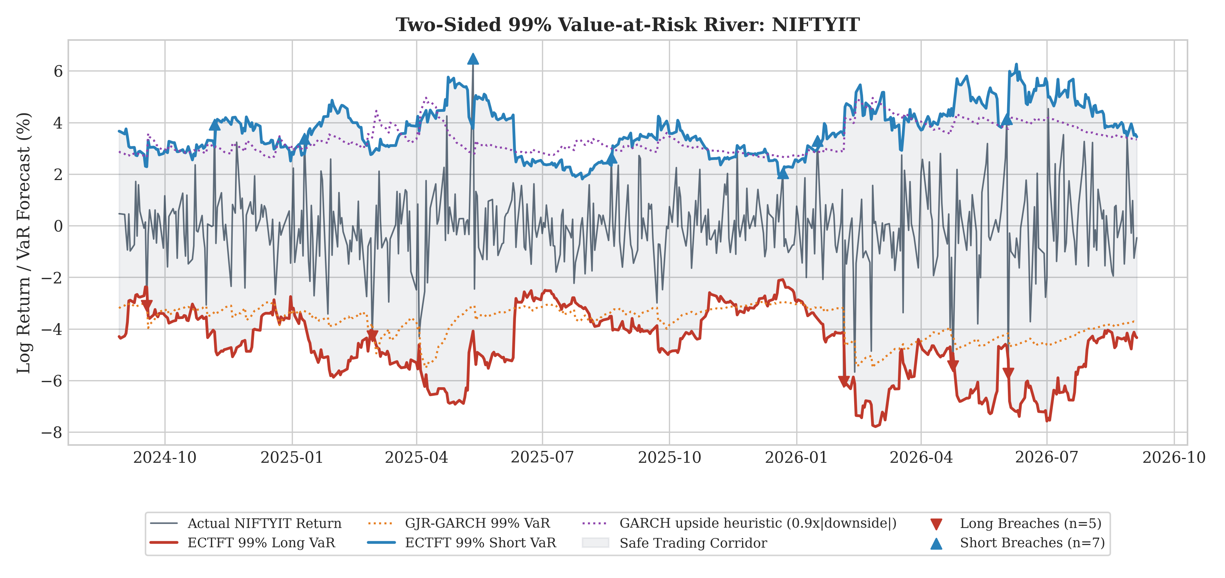
Figure 4c. NIFTYIT two-sided 99% VaR risk river.

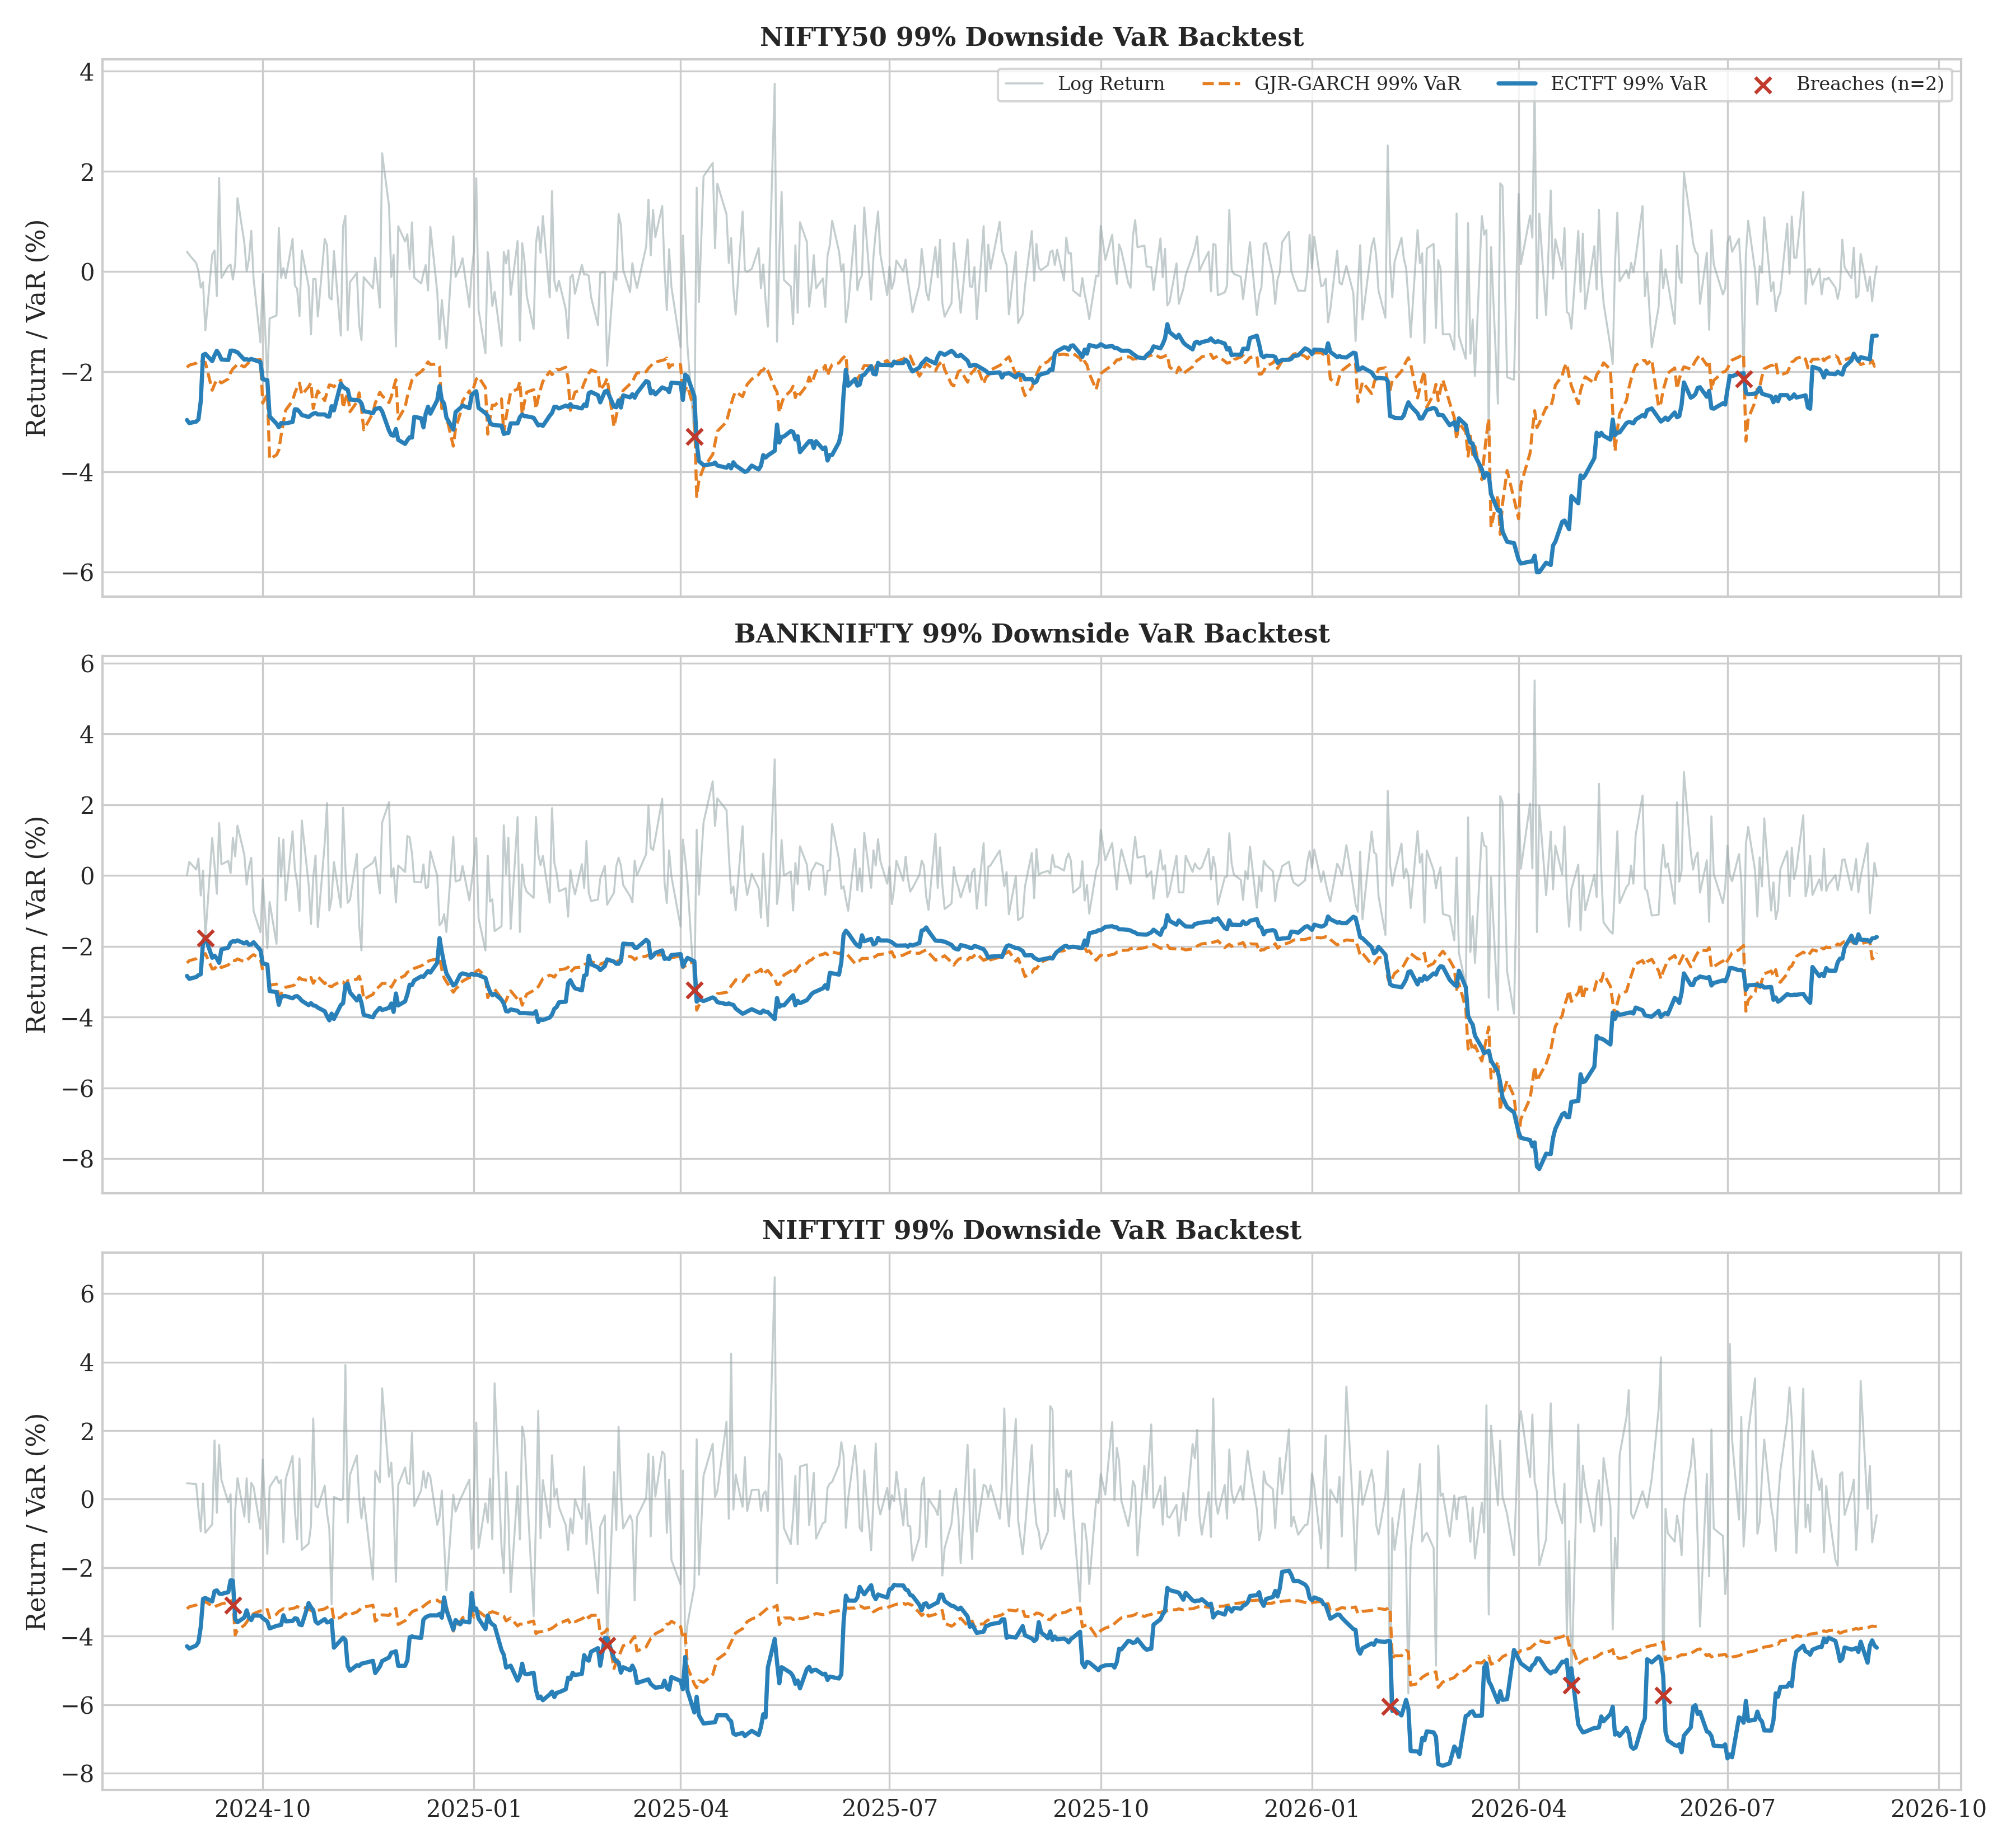
Figure 5. VaR tracking and exception audit.

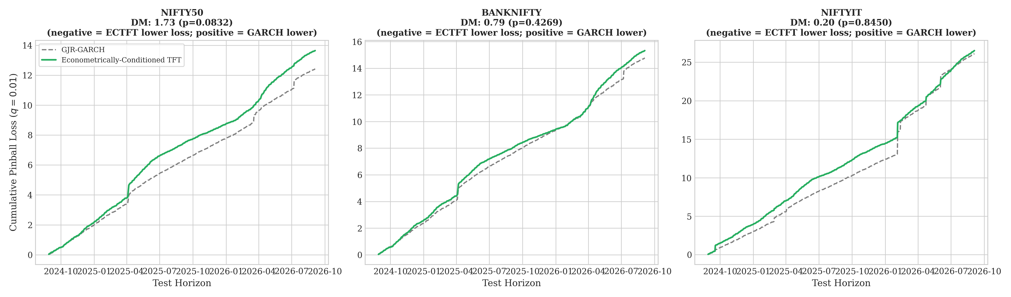
Figure 6. Cumulative pinball-loss trajectories.

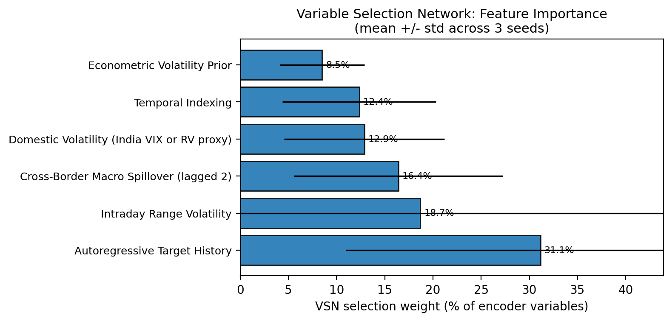
Figure 7. VSN feature-allocation summary.

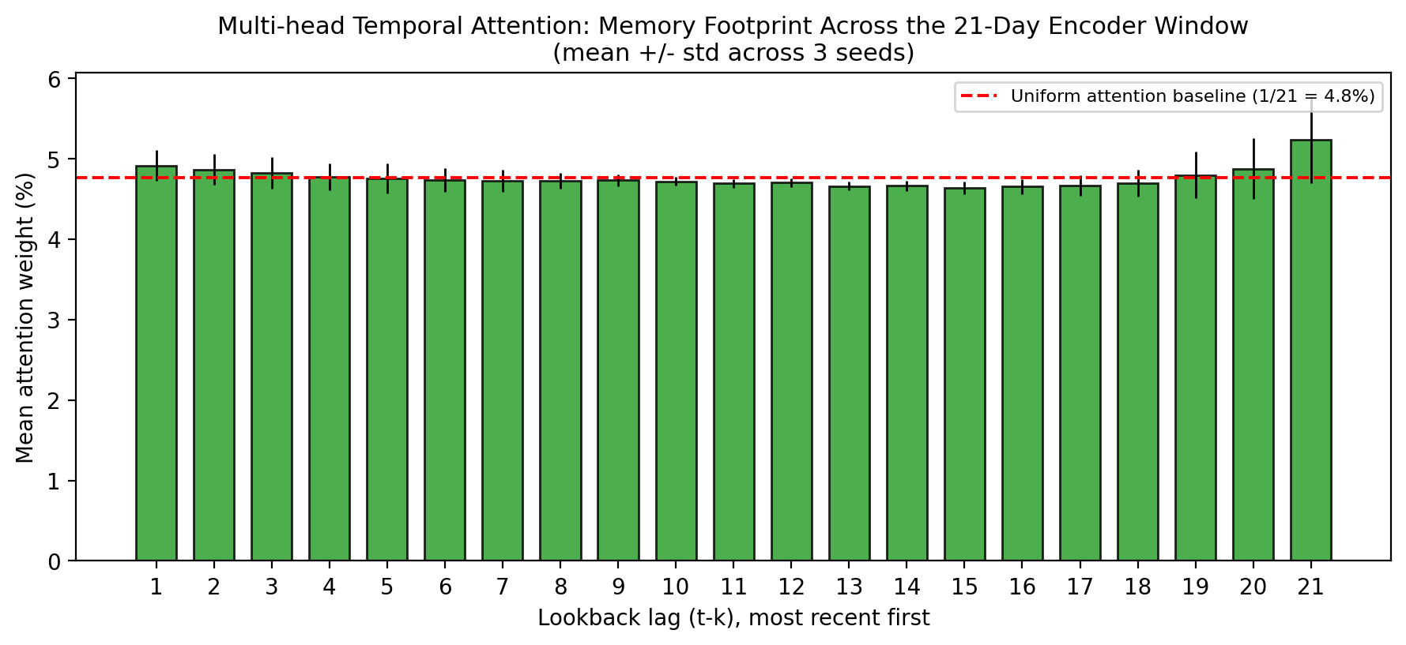
Figure 8. Temporal attention footprint across the 21-day encoder.

References
Black, F. (1976). Studies of stock price volatility changes. Proceedings of the 1976 Meetings of the Business and Economic Statistics Section, American Statistical Association, 177–181.
Bollerslev, T. (1986). Generalized autoregressive conditional heteroskedasticity. Journal of Econometrics, 31(3), 307–327.
Christoffersen, P. F. (1998). Evaluating interval forecasts. International Economic Review, 39(4), 841–862.
Diebold, F. X., & Mariano, R. S. (1995). Comparing predictive accuracy. Journal of Business & Economic Statistics, 13(3), 253–263.
Engle, R. F. (1982). Autoregressive conditional heteroskedasticity with estimates of the variance of United Kingdom inflation. Econometrica, 50(4), 987–1007.
Engle, R. F., & Manganelli, S. (2004). CAViaR: Conditional autoregressive value at risk by regression quantiles. Journal of Business & Economic Statistics, 22(4), 367–381.
Glosten, L. R., Jagannathan, R., & Runkle, D. E. (1993). On the relation between the expected value and the volatility of the nominal excess return on stocks. The Journal of Finance, 48(5), 1779–1801.
Granger, C. W. J. (1969). Investigating causal relations by econometric models and cross-spectral methods. Econometrica, 37(3), 424–438.
Hansen, B. E. (1994). Autoregressive conditional density estimation. International Economic Review, 35(3), 705–730.
Hansen, P. R., Huang, Z., & Shek, H. H. (2012). Realized GARCH: A joint model for returns and realized measures of volatility. Journal of Applied Econometrics, 27(6), 877–906.
Kupiec, P. H. (1995). Techniques for verifying the accuracy of risk measurement models. Journal of Derivatives, 3(2), 73–84.
Lim, B., Arık, S. Ö., Loeffler, N., & Pfister, T. (2021). Temporal fusion transformers for interpretable multi-horizon time series forecasting. International Journal of Forecasting, 37(4), 1748–1764.
McNeil, A. J., & Frey, R. (2000). Estimation of tail-related risk measures for heteroscedastic financial time series: An extreme value approach. Journal of Empirical Finance, 7(3–4), 271–300.
Petrosino, M., et al. (2025). A GARCH-temporal fusion transformer model for the volatility prediction of exchange traded funds. The Journal of Supercomputing, 81, Article 426.
Vaswani, A., Shazeer, N., Parmar, N., Uszkoreit, J., Jones, L., Gomez, A. N., Kaiser, Ł., & Polosukhin, I. (2017). Attention is all you need. Advances in Neural Information Processing Systems, 30.
Zeng, A., Mciver, M., Xu, W., & Wang, Y. (2023). Are transformers effective for time series forecasting? Proceedings of the AAAI Conference on Artificial Intelligence, 37(9), 11121–11128.

